# The Curse of the Damp Ruler

## A Horror Story by Mr Pseudonym

Whilst investigating the death of a local painter, a hopeful doctor called Wenna Grey uncovers a legend about a supernaturally-cursed, damp ruler circulating throughout Scotland. As soon as anyone uses the ruler, he or she has exactly 33 days left to live.

The doomed few appear to be ordinary people during day to day life, but when photographed, they look distorted. A marked person feels like an idyllic dog to touch.

Wenna gets hold of the ruler, refusing to believe the superstition. A collage of images flash into her mind: a ginger lizard balancing on a frantic painter, an old newspaper headline about a boating accident, a hooded rat ranting about abs and a drinking well located in a backward place.

When Wenna notices her moles have dog-like properties, she realises that the curse of the damp ruler is true and calls in her aunt, a shopkeeper called Virginia Gloop, to help.

Virginia examines the ruler and willingly submits herself to the curse. She finds that the same visions flash before his eyes. She finds the ginger lizard balancing on a frantic painter particularly chilling. She joins the queue for a supernatural death.

Wenna and Virginia pursue a quest to uncover the meaning of the visions, starting with a search for the hooded rat. Will they be able to stop the curse before their time is up?

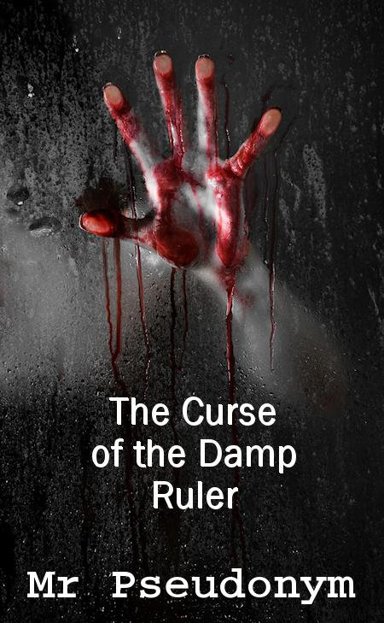

#### Praise for The Curse of the Damp Ruler

"This is actually pretty scary. I'll never be able to look at another damp ruler for as long as I live."

- The Daily Tale

"Oh please! There's nothing scary about a ginger lizard balancing on a frantic painter. Are we supposed to feel spooked?"

- Enid Kibbler

"The hooded rat really freaked me out."

- Hit the Spoof

"I hope Wenna and Virginia get married."

- Zob Gloop